II. Academic
- Undergraduate Program

The undergraduate program is divided into three sub-divisions: Political Theory, International Relations, and Public Administration. Each currently accepts around 50 students per year. In response to a changing environment and the diverse course demands of students, the department has since 2008 offered an Honors Program and a Regular Program for students to choose.

The Regular Program has fewer course requirements, compared to the Honors Program; aside from basic departmental training, students are given room to take courses in other areas.

The department’s course requirements are as follows:

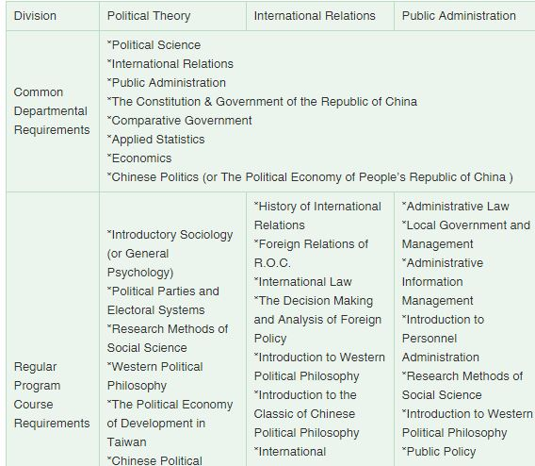
- Master’s Program
The curriculum is divided into two main fields:
(1) Political Theory
(2) International Relations

Every student should select one field as their major. Before graduation, they should take all of the required courses in their major field, as well as a minimum of 3 limited elective courses in their major field. In addition, after completing 3 or more courses in their major field, they must complete a master’s thesis before receiving the MA degree.

2-1 Political Theory
Required Courses
- Seminar on Chinese Political Thoughts
- Seminar on Western Political Thought in the Classical and Medieval Period
- Seminar on Modern Western Political Thought
- Seminar on Preparing Dissertation and Theses
Limited Elective Courses
- Seminar on Western Political Thought in the Classical Period
- Seminar on Modern Political Philosophy in the West
- seminar on Materials Concerning Politics of Ancient China
- Seminar on Materials Concerning Politics of Modern China
- Seminar on Democratic Politics Theory
- Seminar on Methodology of History of the Political Thoughts
2-2 International Relations
Required Courses
- Seminar on the International Relation Theory
- Seminar on Foreign Policy Analysis
- Seminar on Problems of International Law
- Seminar on Preparing Dissertation and Theses
- Second Foreign Language
Limited Elective Courses
- Seminar on Statistical Methods of Social Science
- Seminar on Negotiation and Conflict
- Seminar on ROC Foreign Policy History
- Seminar on International Political Economy
- Seminar on Globalization
- Doctoral Program
The principal goal of the doctoral program in political science is the training of scholars. Most students who receive doctorates in the program will do research and teach at colleges or universities. We offer courses and research opportunities in a wide variety of fields in the discipline, including Political Theory and International Relations. The program is built around small seminars that analyze critically the literature of a field or focus on a research problem. These courses prepare students for their doctoral comprehensive exam requirement within a two-year period and for work on the doctoral dissertation.
3-1 Political Theory
Required Courses
- Seminar on Modern Western Political Thought
- Seminar on Preparing Dissertation and Theses
Limited Elective Courses
- seminar on Materials Concerning Politics of Ancient China
- Seminar on Materials Concerning Politics of Modern China
- Seminar on Democratic Politics Theory
3-2 International Relations
Required Courses
- Seminar on Foreign Policy Analysis
- Seminar on Preparing Dissertation and Theses
- Second Foreign Language
Limited Elective Courses
- Seminar on Negotiation and Conflict
- Seminar on International Political Economy
- Seminar on Globalization

- Dual Degree Program
Dual Degree Program Between NTU and Waseda University
Double Degree Program Between NTU and Waseda University was the first double degree in National Taiwan University, and it offers degrees in SPSE and SILS since 2006. Students who successfully apply have to study in the Waseda campus for 3 semesters along with completing 64 credits by April the next year, while finishing graduation requirements of NTU.

The applicants are required to attach documents of passing JLPT 1st level or getting 220 above in EJU test as language certificates. An attached reference letter in Japanese proficiency is also acceptable while the applicant is obligated to obtain language requirement before completion of Double Degree Program. Applications for studying in SILS require obtaining one of the three standards below:

At least scores 550 in Paper-based TOEFL(PBT)
At least scores 213 in Computer-based TOEFL(CBT)
At least scores 80 in New Internet-based TOEFL(iBT)

Admission for application starts from October. Please read the latest news on our website. The recommended applicants will be announced in December by Department of Political Science and official admission papers will be released by Waseda University in mid-March of the following year.

Required documents of Application of SPSE and SILS are listed below:
