**IV. Faculty and Staff**

1. 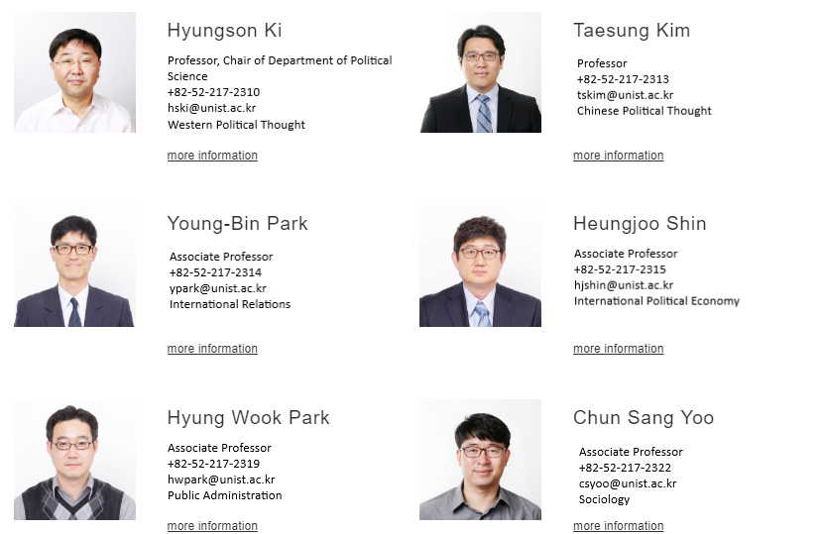**Faculty**
2. **Staff**

