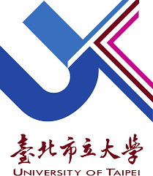
LOGO

MEMORANDUM OF UNDERSTANDING
between
COLLEGE/DEPARTMENT/CENTER NAME, UNIVERSITY OF TAIPEI
AND
COLLEGE/DEPARTMENT/CENTER NAME, UNIVERSITY NAME

College/Department/Center Name, University of Taipei (UT) and College/Department/Center Name, University Name (XXX) are exchanging this agreement to develop a spirit of amity with each other.
- This agreement aims to promote academic cooperation between University of Taipei and University Name.
- The two colleges agree to seek possible ways to:
a. exchange academic materials and information;
b. receive mutual educational visits by faculty and staff;
c. exchange students and visiting scholars;
d. hold joint international conferences;
e. conduct joint research projects;
f. engage in other activities to better enhance mutual understanding and cooperation.
- The agreement is effective from the date of signature for a period of five years and may be modified through mutual consent. It shall be extended automatically for an additional period of five years at each expiration date unless either party gives a written notice six months in advance to terminate the agreement.

Name Name
Title, College/Department/Center Name Title, College/Department/Center Name
University of Taipei , University Name
Date: Date:

