109.12.30版本

臺北市立大學

學生出國研修心得報告
獲補助年度：113
研修領域：商管
系所、年級：都會產業經營與行銷學系四年級
學生姓名：王唯瑀
研修國家：英國
研修學校(中英文)：University of Essex 艾塞克斯大學

研修時間：中華民國 113 年 8 月 11 日至 114 年 9 月 16 日

國外研修成績：72.0
短片時間及標題：https://youtu.be/P9efl0s-uzs

中華民國 114 年 9 月 26 日

*(非亞洲地區交換同學請以英文撰寫報告)
目 錄
(請以標楷體14號，行高1.5繕打，並標示頁碼)

壹、 緣起 1
貳、 研修學校簡介 1
參、 國外研修之課程學習(課內) 1
肆、 國外研修之生活學習(課外) 1
伍、 研修之具體效益(請條列式列舉) 1
陸、 感想與建議(含3分鐘短片連結) 2

- 緣起

Before departing for the UK through the MOE scholarship, I prepared by applying for a UK student visa, NHS and purchasing one-year Europe-wide insurance. Since this was a dual-degree program with my university in Taiwan, the application process was simpler, requiring fewer documents. I chose school accommodation with an ensuite room and applied through the university’s website. Before leaving, I also took the IELTS exam to ensure my English readiness. I researched course options and daily necessities, and carefully packed study materials. These preparations reduced uncertainty, enabling me to adapt smoothly upon arrival and focus on study and life abroad.

- 研修學校簡介

I studied at the Southend campus of the University of Essex, under the International Marketing and Business Intelligence program. Unlike the main Colchester campus, Southend is smaller and hosts mainly the Essex Business School, meaning the entire campus consists almost exclusively of international students. I never encountered local British students in class, which created a unique global learning atmosphere. The campus is located in Southend-on-Sea city center, making it very convenient for shopping and daily needs, and only a short walk from the seaside. Although smaller, the location offered a pleasant living environment and easy access to local resources.

- 國外研修之課程學習(課內)
My coursework included modules such as Strategic Management, Innovation Management, Sustainable Business, Digital Marketing and Social Media, Research Methods and International Marketing Strategy and Planning. Most subjects were not extremely difficult since I had studied similar topics during undergraduate years, but the workload was much heavier. Almost every class required a 2,000-2,500 word essay, and some included group presentations. The most impressive course for me was Sustainable Business, which emphasized the link between corporate responsibility and global development. The intensive assignments trained me in academic writing, critical thinking and project collaboration, which significantly strengthened both my professional knowledge and research ability.

- 國外研修之生活學習(課外)
I lived in the university’s ensuite dormitory, where my monthly living expenses were supported by £1,000 from my family. Cooking meals myself kept costs manageable, and most of the time I stayed in my accommodation to focus on studies, as each term lasted only 10 weeks and coursework was demanding. Since Southend campus lacked student societies and had limited activities compared with Colchester, social life mainly depended on classmates. Luckily, I met eight other Taiwanese students, and we often cooked and dined together, which helped reduce homesickness.
Although campus events were limited, the location made traveling convenient during holidays. It was easy and affordable to explore other European countries, which greatly enriched my experience. One of the biggest challenges was adjusting to the UK’s public transport system, as trains often broke down, the tube went on strike and flights were frequently delayed. These unpredictable situations taught me patience and problem-solving skills. Overall, living abroad made me far more independent, capable of cooking, budgeting, and handling unexpected challenges by myself. These lessons extended beyond academics and became a crucial part of my personal growth.

- 研修之具體效益
- Improved English proficiency and academic writing through full immersion.
Studying entirely in English enhanced not only my communication skills but also my ability to write academic essays and research reports with confidence.
- Gained professional skills in international marketing, strategy and sustainability.
Courses such as Sustainable Business and International Marketing Strategy deepened my knowledge of current business practices and prepared me for future career challenges.
- Enhanced independence by managing daily life, including cooking and budgeting.
Living alone required me to plan meals, manage expenses and make decisions independently, which developed strong self-management skills.
- Learned adaptability in dealing with transport delays and unexpected events.
Frequent train cancellations and flight delays in the UK taught me to stay calm, adjust quickly and find alternative solutions.
- Built strong friendships with international classmates, especially fellow Taiwanese students.
These connections provided emotional support, cultural exchange and a sense of belonging during my studies abroad.
- Experienced cultural exchange with peers from diverse backgrounds.
Working on group projects with classmates from different countries exposed me to various perspectives and enriched my global outlook.
- Developed problem-solving and resilience when facing challenges abroad.
From academic pressures to daily inconveniences, I learned to handle difficulties constructively, which boosted my confidence.
- Benefited from the dual-degree structure by saving one year of study time.
This allowed me to complete my master’s earlier than peers, offering a valuable advantage in both time and career planning.
- Prepared earlier for entering the job market with international experience.
The overseas learning and living experiences gave me unique qualifications that will help distinguish me in future professional opportunities.

- 感想與建議(含3分鐘短片連結)
Participating in the MOE program and studying at the University of Essex was an invaluable opportunity for me. Through this dual-degree program, I was able to begin my master’s studies earlier than most of my peers and save an additional year compared to applying independently. This allowed me to gain not only academic knowledge but also more time to prepare for future career development.
The program greatly improved my English proficiency, since I had to communicate in English in both academic and daily settings. More importantly, I developed independence and problem-solving skills. Living alone required me to cook, manage expenses and handle unexpected events by myself. Public transportation issues in the UK, such as frequent train cancellations and flight delays, initially frustrated me, but eventually taught me to stay calm and adapt flexibly to challenges.
For students considering this program, I strongly recommend it for those who value efficiency and want to graduate earlier. The dual-degree pathway reduces paperwork and guarantees admission, making the process much easier than independent applications. However, I also recognize that some peers who applied by themselves were able to attend universities with higher global rankings. Therefore, if one’s priority is the reputation of the institution, it may be worth considering other options.
Overall, I found the MOE program very worthwhile. It gave me an earlier start in postgraduate education, helped me gain cultural and academic experiences abroad and allowed me to accumulate work experience sooner than others. For future applicants, my advice is to maintain good academic performance before applying, as this is the key selection criterion. Even if earlier grades are not ideal, this program still provides a second chance. Ultimately, the experience taught me resilience, independence and confidence, which I will carry into my future career.
具代表性出國交換照片說明(4張)
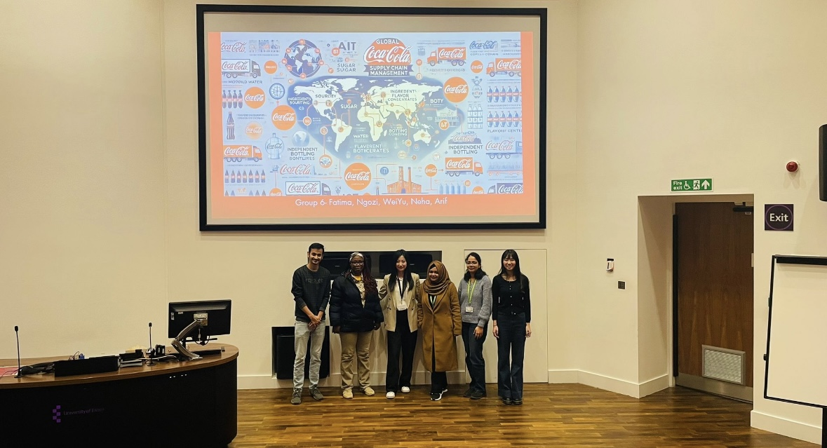
Presenting our group project in Global Supply Chain Management, analyzing Coca-Cola’s complete supply chain process from production to delivery.
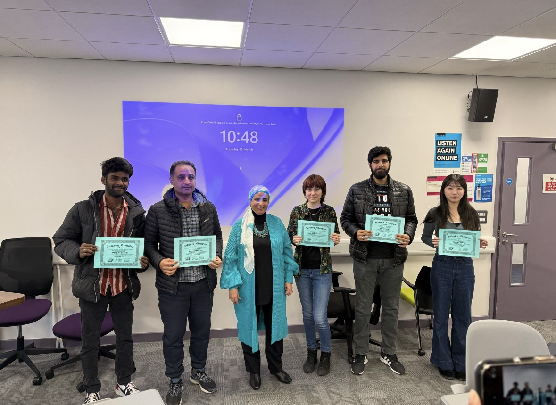
Our team achieved first place in the GLO-BUS competition in International Marketing Planning and Strategy this course, adjusting data weekly and competing with classmates.
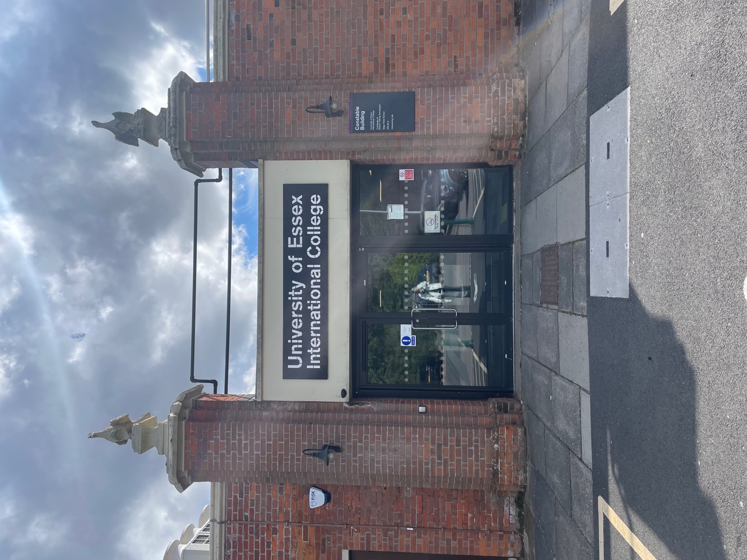
Joining pre-sessional classes at Colchester campus, learning British history and culture while making new international friends.
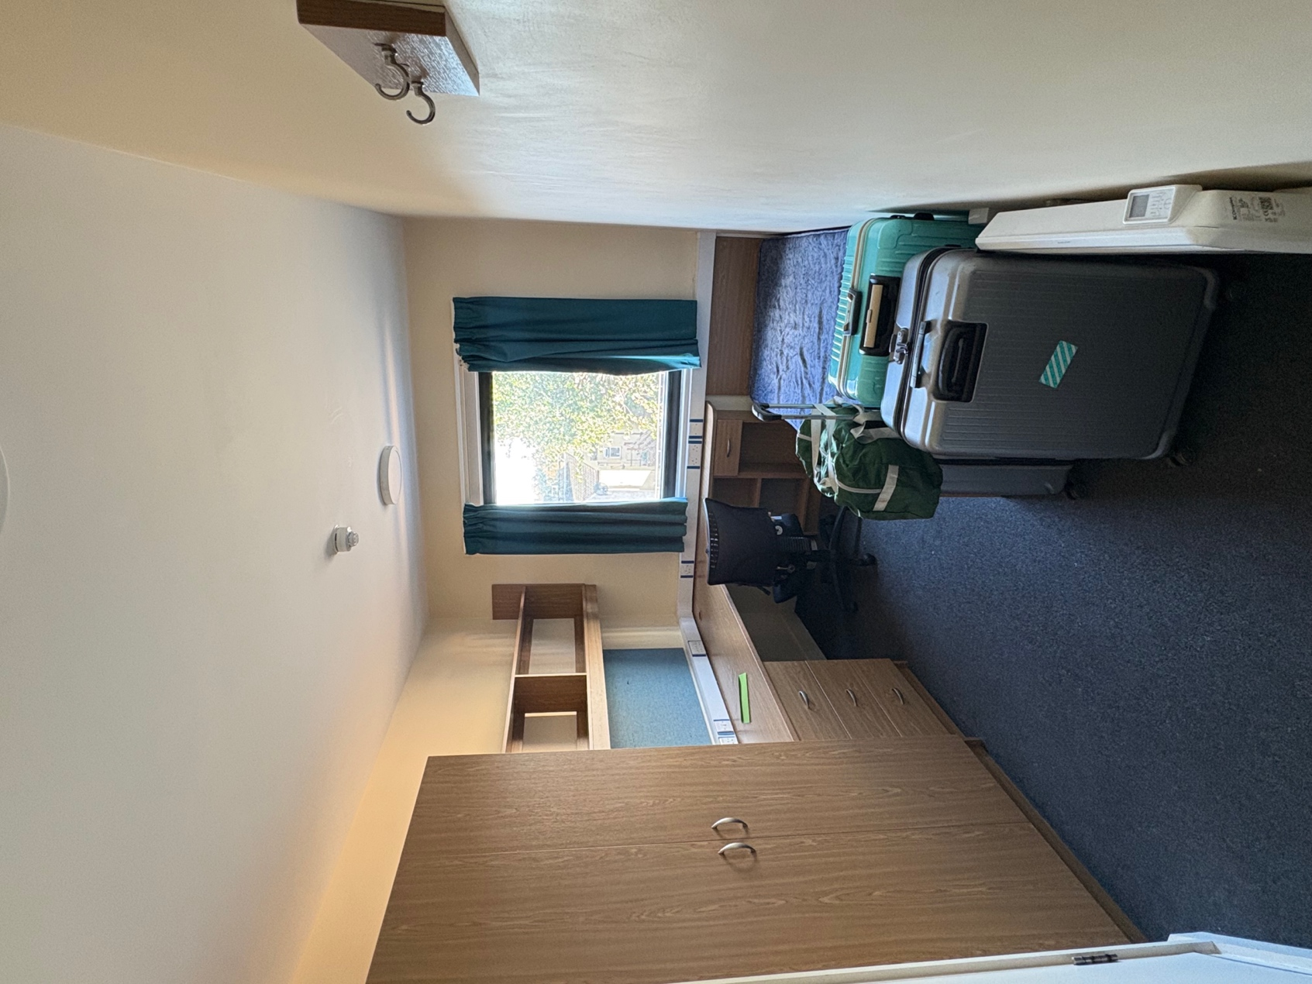
My ensuite dormitory room at Southend campus—though compact, it was cozy and became a warm, comfortable home.

